**Borrow: e-Library Management System**

Made by Reymar Dela Paz

Table of Contents

Objectives 3

Who are the users? 4

# Objectives

The main objective of this project is to have an overall useful library management software that can be able to manage librarians by an admin and librarians can add, maintain, delete books, issue books to students and return books as well.

# Who are the users?

There are two main classifications of users:

1. Admin – The admin is capable of maintaining the librarians. He or she can enroll librarians, maintain librarian details, or even delete librarians.
2. Librarians – The librarians are capable of adding books, maintaining information of the books, deleting books, issuing books to students and returning books.

# Tech Stack

**BACK-END: Java Servlet, MYSQL database**

**FRONT-END: HTML, JSP, CSS**

# Tools and Software

1. MYSQL database
2. IDE – Personally, the developer used Eclipse for the development of this project. This is done with Apache Tomcat Server

# Website Walkthrough

## Home Page

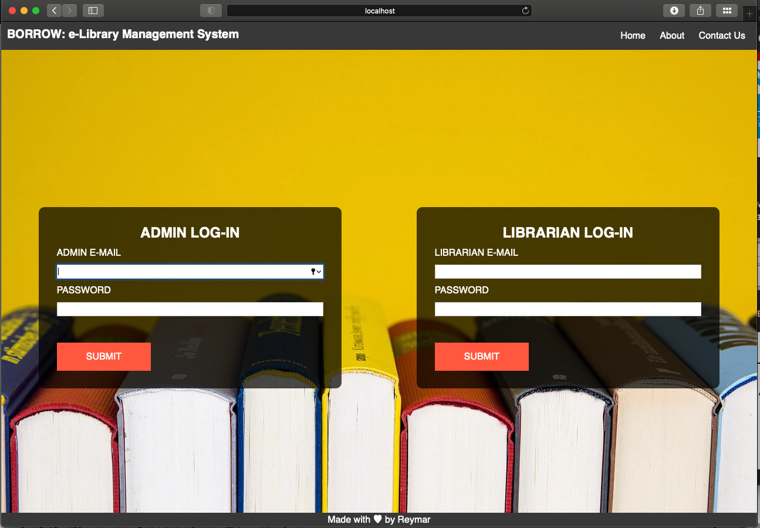

The homepage has a navigation menu at the top where it contains the name of the project, as well as Home, About and Contact Us options. There are also two log-in options, one for admin, and one for the librarian.

## Admin – Home

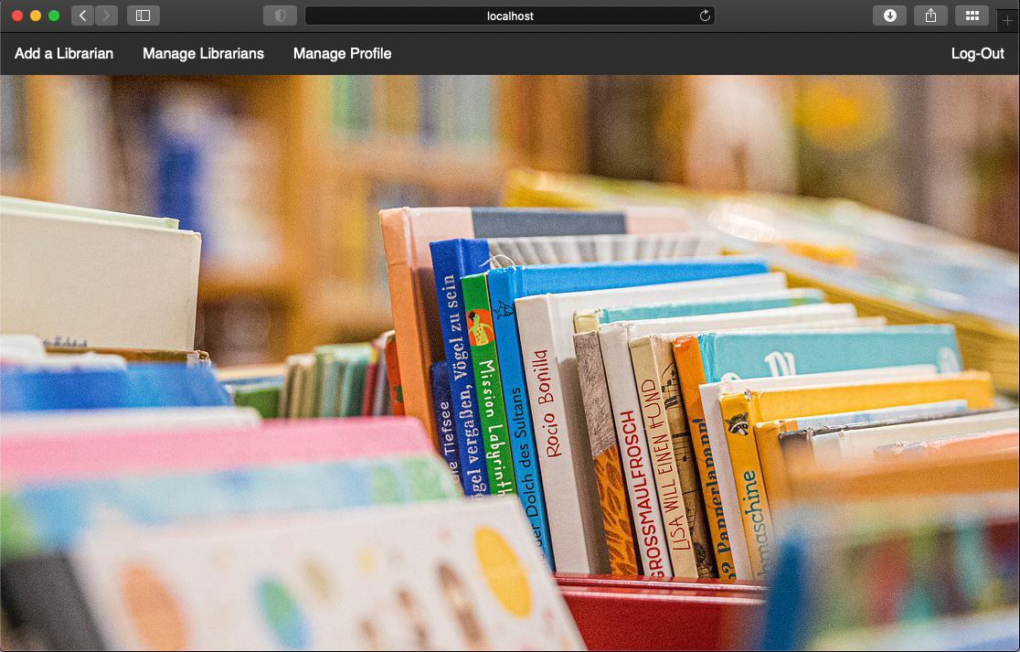

The navigation bar inside the Admin-Home has 4 options. Add a Librarian, Manage Librarians, Manage Profile and Log-Out. Let us have a look on each of these options.

## Admin – Add a Librarian

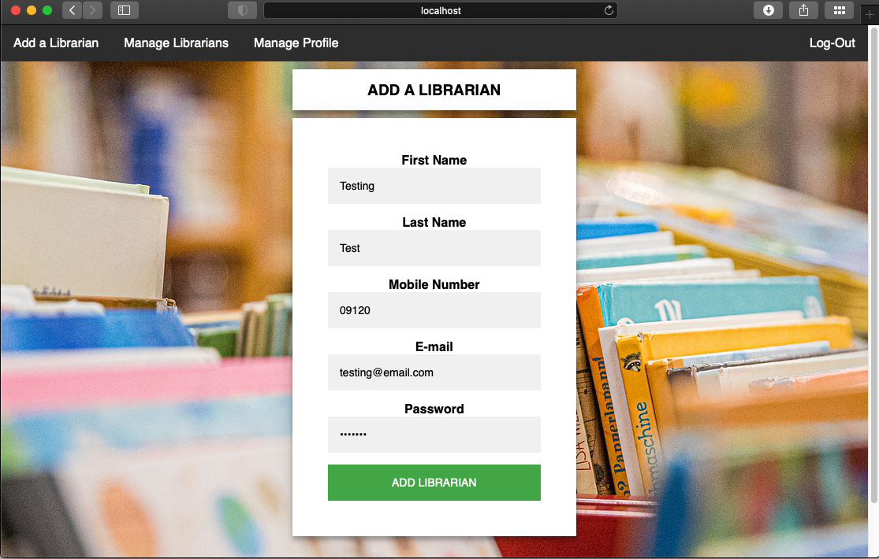

The Add a Librarian option has 5 input fields. All of these fields are required in order to add a librarian. Upon successful addition, it will update the database and the admin will be able to manage the librarian via the Manage Librarians option.

## Admin – Manage Librarians

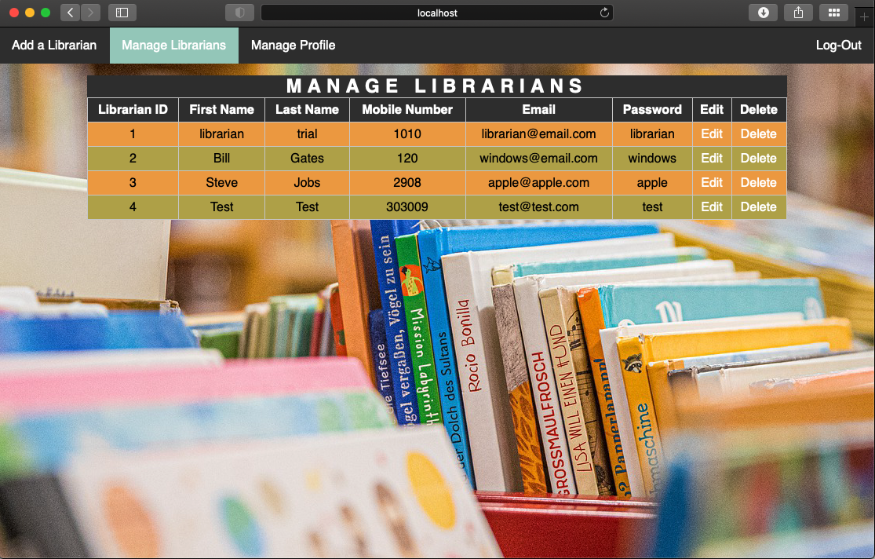

The Manage Librarians option presents a table containg the information and details of the librarians. There are two sub-options under this, the edit and delete options.

## Admin – Edit Librarian Form

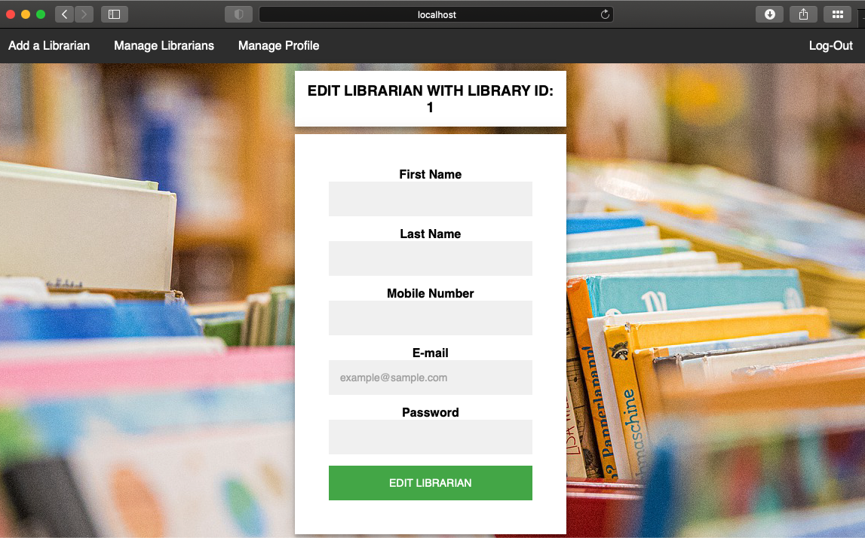

## Admin – Manage Profile

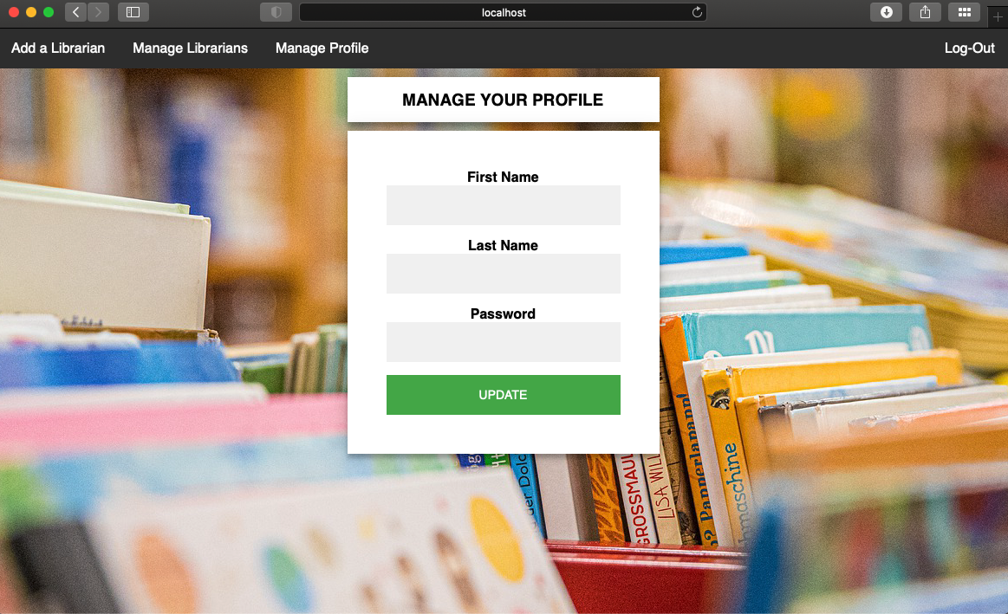

The Manage Your Profile allows the admin to maintain his or her information like first name, last name, and password.

## Admin – Log-Out



Log-out option terminates the session and redirects the user to the home page.

## Librarian – Home

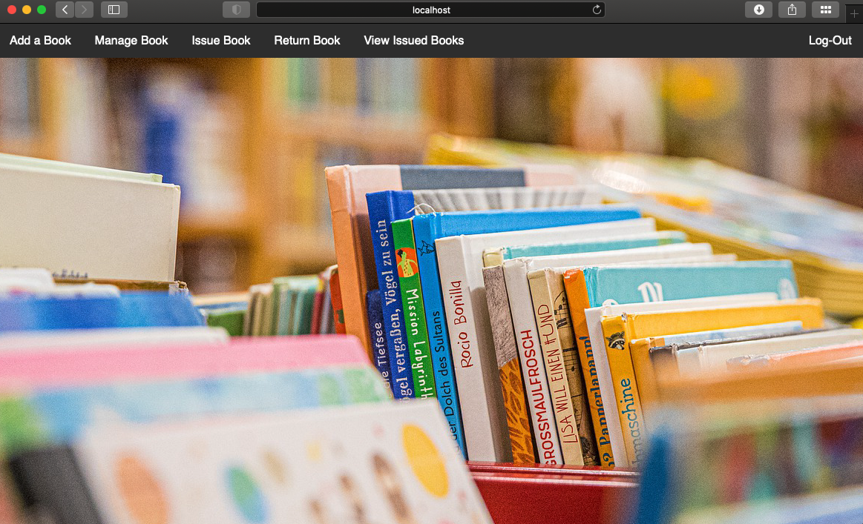

The navigation bar inside the Librarian-Home has 6 options. Add a Book, Manage Book, Issue Book, Return Book, View Issued Books and Log-out.

## Librarian - Add a Book

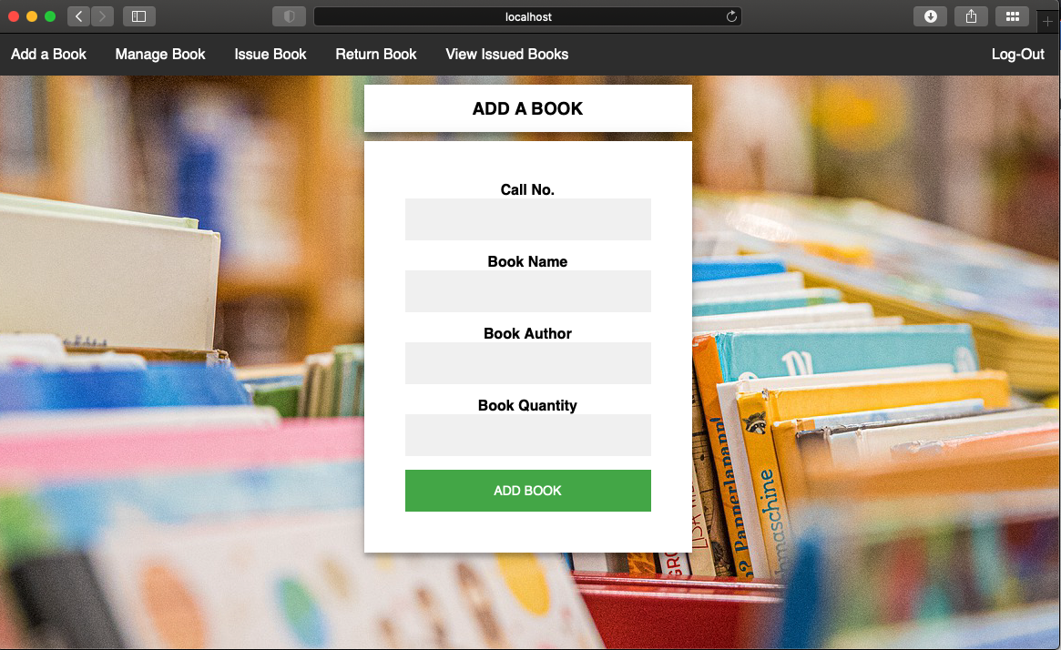

There are four required fields under the form. The call number, which serves as reference number of the book, the book name, book author and the book quantity.

## Librarian – Manage Book

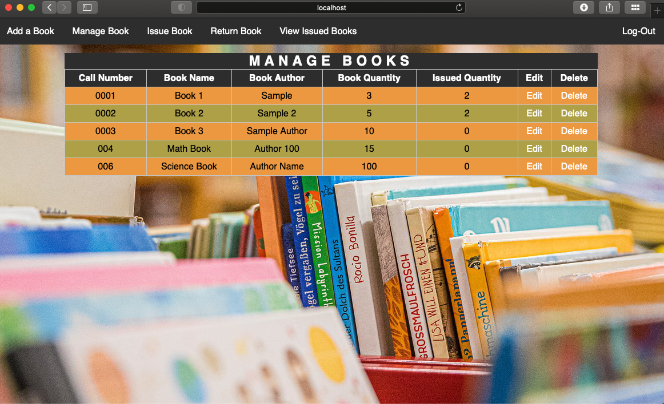

Under Manage Books option, a table is presented with the details and information about all the books in the database. The librarian can edit information and delete via the specified buttons.

## Librarian – Edit Book

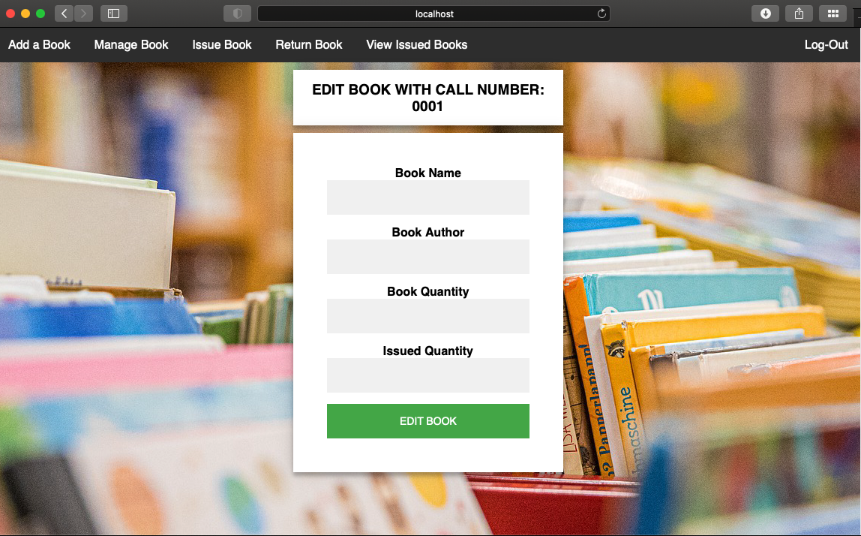

## Librarian – Issue Book

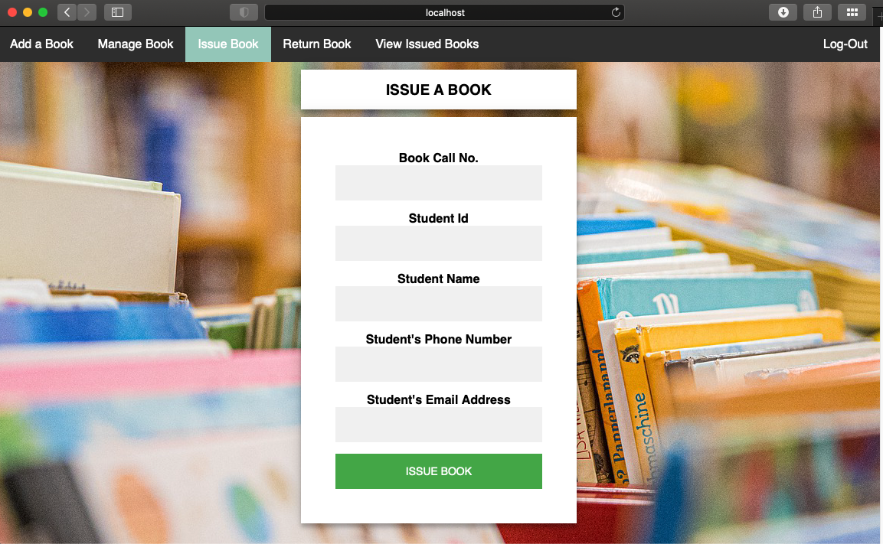

The issue book option has 5 required input fields. The Book call number, student ID, student name, student phone number and student email address. Note that you cannot add a book which has invalid or incorrect book call number, or the book trying to be issued has 0 quantity left.

## Librarian – Return Book

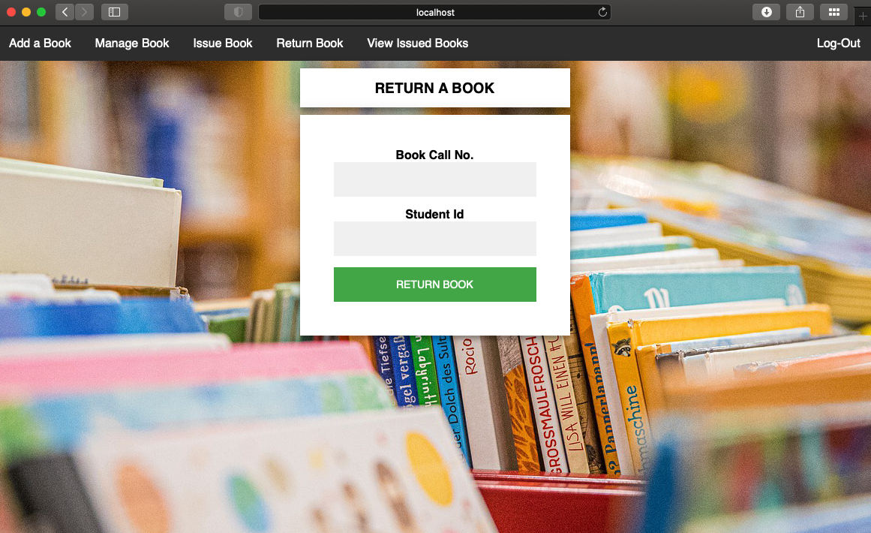

The return book option has two required fields, the book call number and the student ID. Updating this will also update the database, specifically the book’s quantity.

## Librarian – View Issued Books

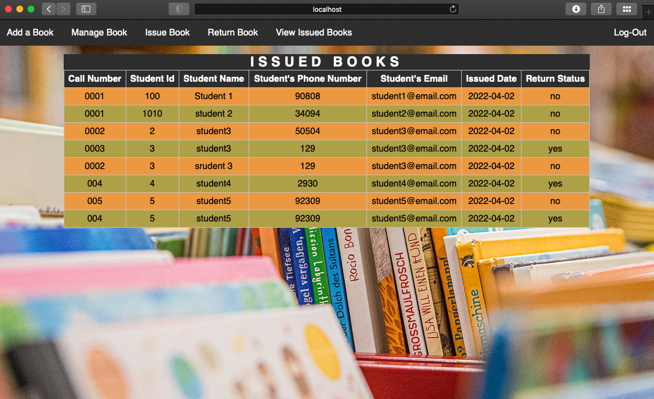

The View Issued Books will just show the return status of the issued books as well as other useful information about them.

## Librarian – Log-Out



Log-out option terminates the session and redirects the user to the home page.

# Developer’s Notes

Please feel free to contact and connect with me through my linked-in account below. Thank you!

<https://www.linkedin.com/in/reymar-dela-paz-0a26a0196/>